American Journal of Engineering Research (AJER)
e-ISSN : 2320-0847 p-ISSN : 2320-0936
Volume-1 pp-54-58
www.ajer.org

Research Paper Open Access

Bond characteristic of rebar in concrete with manufactured sand as fine aggregate

Sureshbabu N.¹, Job Thomas ²
¹Lecturer in civil Engineering, Kerala Government Polytechnic College, Kozhikode, Kerala,
India
²Reader in Civil Engineering, School of Engineering, Cochin University of science and
Technology, Kerala, India

Abstract: - The In this experimental work an attempt is made to investigate the bond characteristics of deformed steel bars in concrete containing manufactured sand /river sand as fine aggregate. The aspect studied include the bond stress and slip of reinforcement embedded in concrete specimens. The variables considered for the study include type of fine aggregate, diameter of reinforcement bar, and the position of bar placement. The variables considered for the study include type of fine aggregate, diameter of reinforcement bar, and the position of bar placement. The rebar bond strength of concrete containing manufactured sand as the fine aggregate is found to be superior when compared to concrete containing river sand.

Keywords: - Bond strength, ,Manufactured sand, Pull out test, River sand, Slip

INTRODUCTION
River Sand is the commonly used as fine aggregate in concrete construction. Due to the continuous mining of sand from riverbed led to the depletion of river sand and it became a scarce material. Also sand mining caused a lot of environmental issues, such as lowering of river beds, lowering of surface water level in rivers. As a substitute to river sand, manufactured sand has been produced by crushing stone. Some experimental results show that the engineering properties of manufactured sand. Some related studies show that manufactured sand is a suitable and viable substitute for river sand, manufactured sand could be effectively used in concrete construction, which provides adequate strength and durability for the concrete.
The experimental study on concrete with manufactured sand as fine aggregate has been carried out in this study. The bond-slip behavior of reinforcement and surrounding concrete, maid of manufactured sand and river sand as fine aggregate has been studied. The pull out specimens with reinforcing bar having diameter of 10 mm and 16 mm were prepared and tested. The variables considered for the study include type of fine aggregate, diameter of reinforcement and concrete cover to the reinforcing bar. It is expected that the test results are useful for promoting the use of manufactured sand in construction industry.

OBJECTIVES OF THE STUDY
The objectives of the study are to determine the pullout strength, slip corresponding to the pullout force in rebar embedded in concrete with difference cover thickness. Concrete made with river sand and manufactured sand has been used in this study.

REVIEW OF LITERATURE
Torre-Casanova [1] conducted an experiment on confinement effects on the bond strength of concrete with steel and pull-out failure and find the effect of active and passive confinement on the bond strength of concrete by conducting pull out test and find that the bond strength is increasing by active confinement.
Pul [2] conducted a test on loss of concrete-steel interface bond strength under monotonic and cyclic loading of lightweight and ordinary concretes and in this study, loss of concrete-steel bond strength of lightweight and ordinary concrete under monotonic and cyclic loading is examined for plain and deformed steel bars ordinary concrete-steel bond strength is greater than lightweight concrete-steel bond strength under both monotonic and cyclic loading for deformed steel bars. The loss of concrete-steel bond strength is greater in plain bars than in deformed bars.
Ahmed et al. [3] conducted an experiment on the effect of rebar cover and development length on bond and slip in high strength concrete by conducted pull out test on HSC with 13 mm bar and find that the cover to diameter ratio and development length on high strength concrete and also find that the failure occur due to brittle failure, and when slip of reinforcement occur, the formation of longitudinal splitting cracks occurs simultaneously bond strength reduces drastically.
Bamonte et al. [4] conducted a study on size effect and lead bond stress – slip law. As per the study the size effect is studied with reference to the bonding of short deformed bars embedded on normal strength concrete and HPC. The bonded length to bar diameters is taken as 5 for NSC and 3.5 for HPC. As per the result the highest stress values for the smallest diameter. In the experiment it was observed that the peak bond stress is markedly affected by the bar diameter with the highest stress value for the smallest diameter.
Dancygier et al. [5] studied the bond between deformed reinforcement and normal and high-strength concrete with and without fibers.. Parameters that affect the concrete-steel bond properties include concrete density, concrete cover, aggregate type, confinement conditions, diameter, location and orientation of the reinforcing bar, and mix additives such as silica fume or fibers.
Byunghwan et al. [6]Introduced a realistic model for local Bond stress slip of Reinforced concrete with river sand as fine aggregate and they adopt a special arrangement for the loading system for bond tests. The steel is of nominal diameter16 mm. The average compressive strength of concrete was 37 MPa and the aggregate used was 13 mm maximum size crushed stone and river sand. In this test it was analyzed the variation of Bond strength and slip at the peak Bond stress after repeated loading. In this study the Bond stress Vs slip in repeated loading were analyzed with 3 types
Tayfun and Francois [7] give the effects of bar placement conditions on steel concrete bond. In this report they established that the controlling factors of bond stress of steel reinforcement in concrete are the cover to reinforcement and water cement ratio. The best bond strength results are achieved within a cover depth less than 250 mm. .
Ramesh et al. [8] was conducted study a study on crushed stone dust as fine aggregate in structural concrete. It was 20.5 kNm for sand beam and 18.94 kNm for stone crusher dust beam. Analyzing the test results it is concluded that stone crusher dust qualities itself as a suitable substitute for sand at very low cost.
Sheela [9] was conducting an experiment for the influence of manufactured sand in Ferro cement elements. It is concluded that the workability of manufactured sand specimens was low, but the energy absorption capacity was more. The study indicate that manufactured sand or its combinations with river sand can be effectively used for the replacing the river sand.
Tastani et al. [10] conducted an experiment on direct pull out bond test. It was an experimental investigation of the performance of bond test designed to quantify the lower bound bond properties of steel embedded in normal strength concrete. Conventional pull out test were also conducted and compare the results.
Prakash [11] conducted comparative study on the compressive strength of concrete prepared using manufactured sand, river sand and quarry dust. Concrete mix with water cement ratio of 0.6 was also prepared and strength was found to be 19 MPa, 17 MPa and 14 MPa for concrete with manufactures sand, river sand and quarry dust respectively.

EXPERIMENTAL INVESTIGATION
Constituent materials
The materials used in the casting of specimen are cement, fine aggregate, coarse aggregate, reinforcement, water and admixture. The grade of concrete is fixed as M30 and the water cement ratio adopted as 0.385. Portland pozzalona cement containing fly ash conforming to IS:1489 (1976) [15] is used in this study . The specific gravity of the cement is found to be 2.84 and compressive strength is 49.85N/mm². Two types of fine aggregate, namely, river sand and manufactured sand, are used. River sand having specific gravity of 2.58, bulk density of 1680 kg/m³ and conforming to zone II of IS:383(1970) is used. Manufactured sand of specific gravity 2.68, bulk density1590 kg/m³ and conforming to zone II of IS:383(1970)[12] is used. Crushed granite stone aggregate having nominal size of 20 mm, specific gravity of 2.68 and bulk density1690 kg/m³ is used. Potable water is used for the preparation of concrete
TMT Reinforcement of 10 mm and 16 mm diameters are used with yield strength of 461 MPa. The 10 mm steel bar of rib height of 0.78 mm and the rib spacing of 9.10 mm is used. The 16 mm steel bar of rib height of 1.05 mm and the rib spacing of 11.55 mm is used.

Mix Proportion
The mix proportion of constituents is determined based on the guidelines in IS:10262 (2009)[13] [14]. The mix proportion of different mixes is given Table 1.
Table 1 Mix proportion
Designation of mix | Water (kg) | Cement  (kg) | Fine aggregate (kg) | Coarse aggregate (kg) | Admixture (Liters) | Type of sand
M | 170 | 442 | 595 | 1140 | 3.7 | Manufactured sand
R | 170 | 442 | 572 | 1140 | 3.7 | River sand

Details of Test Specimens
Following type of specimens are cast to study the bond stress - slip relation between reinforcement and concrete by direct pull out test. The size of the cube is 150mm x 150mm x 100mm.and the reinforcement is inserted at different positions so as to get different covers as given in Table 2. The plan and elevation of the specimen is given in Fig 1.

Experimental set up
The pull out test is carried out using 40T universal testing machine. Two dial gauges meters of least count 0.01 mm are attached; one touching the projecting tip of the reinforcement of 10 mm and the other at 250 mm below concrete face on the opposite face. The elongation of the bar is compensated to compute the slip. The difference in readings of the two dial gauge readings is taken as the relative slip of the rebar with the concrete surface. The test set up is shown Fig.2

Table 2 Details of the positioning of reinforcement
Specimen designation | Type of fine aggregate | Cover, a  (mm) | Cover, b  (mm) | Diameter of bar (mm) | Number of specimens
M4040 -D10 | Manufactured sand | 40 | 40 | 10 | 5
M4075-D10 | Manufactured sand | 40 | 75 | 10 | 5
M7575-D10 | Manufactured sand | 75 | 75 | 10 | 5
M4040 –D16 | Manufactured sand | 40 | 40 | 16 | 5
M4075-D16 | Manufactured sand | 40 | 75 | 16 | 5
M7575-D16 | Manufactured sand | 75 | 75 | 16 | 5
R4040 –D10 | River sand | 40 | 40 | 10 | 5
R4075-D10 | River sand | 40 | 75 | 10 | 5
R7575 -D10 | River sand | 75 | 75 | 10 | 5
R4040 -D16 | River sand | 40 | 40 | 16 | 5
R4075-D16 | River sand | 40 | 75 | 16 | 5
R7575-D16 | River sand | 75 | 75 | 16 | 5
* a and b are marked in the Fig 1
.
b
a
Concrete specimen
Steel bar
Plan
Elevation

Fig. 1 Details of the specimen

RESULTS AND DISCUSSIONS
The results obtained from the pull out test conducted in various types specimens cast with manufactured sand and river sand are given in Fig 3 and 4. The bond stress slip response of 10 mm diameter bars are given in Fig 3. It is observed that the bond strength for the concrete specimen containing manufactured sand is higher than the concrete specimen containing river sand. The bond stress slip response of 16 mm diameter bar is given in Fig 4. It is seen that the manufactured sand concrete is having greater bond strength than river sand concrete. But the final stress after 10 mm slip was almost equal to both specimens. The slope of the post peak degradation response curve is found to be almost equal. The radial cracks are observed in the specimen with 16mm diameter bars ( M4040-D16 and R4040-D16)

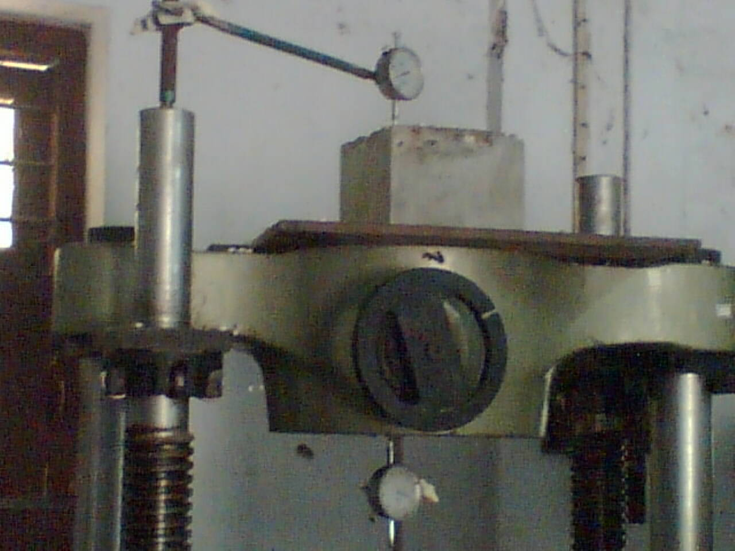
Fig. 2. Bond stress specimen with square cross section

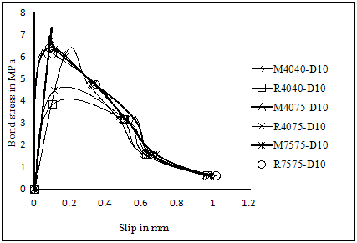
Fig.3.Bond slip response for 10 mm diameter bars

CONCLUSION
Based on the experimental study on the bond slip of rebar embedded in concrete, the following conclusions are derived.
- The bond stress- slip response of rebar in concrete containing manufactured sand is found to be similar to that in river sand concrete
- The bond strength of rebar in concrete with manufactured sand is found to be higher than that that in river sand concrete.
- Radial cracks are observed in concrete specimens of 16 mm diameter rebar with 40 mm cover. This indicates that the cover of 40 mm is not sufficient to mobilize the bond strength.
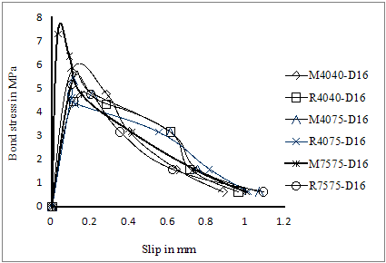
Fig.4.Bond slip response for 16 mm diameter bars

The rebar bond strength of the concrete containing manufactured sand is found to be superior than that concrete containing river sand. Hence, the manufactured sand can be considered as an alternate material and substitute to river sand in reinforced concrete construction. In fact, the development length of rebar can be reduced when manufactured sand concrete is used, which may indirectly lead to economy in construction.

REFERENCES
- A.Torre-Casanova,(2013),Confinement effects on the steel–concrete bond strength and pull-out failure, Engineering Fracture mechanics 97, 92-104
- S.Pul (2010), Loss of concrete-steel bond strength under monotonic and cyclic loading of lightweight and ordinary concretes, Iranian Journal of Science and Technology, Transaction B: Engineering, ,34, B4, 397-406
- Ahmed (2008),The effect of rebar cover and development length on bond and slip in HSC, Pak journal for Engineering and science,.2, 79-87.
- P.F .Bamonte. (2007) ,Study on size effect on the local Bond stress – slip law, Journal of structural engineering ASCE, , 4, 225-234
- Avraham N. Dancygier • Amnon Katz ,Uri Wexler (2009), Bond between deformed reinforcement and normal and high-strength concrete with and without fibers ,Materials and Structures (2010) , 43, 839–856
- [6] Byung Hwan (2007), Realistic models for local Bond stress – slip of reinforced Concrete, Journal of structural engineering ASCE, 133, 216-,220.
- Tayfun A. Söylev and Raoul François(2006), Effects of Bar-Placement Conditions on Steel-Concrete Bond, Materials and Structures, 39, 2, 211-220
- Ramesh (2007), appraisal of crushed stone dust as fine aggregate, CE & CR concreting journal July 2007, 7, 54-58
- Sheela S. (2004), influence of M Sand in ferrocement elements and its application, Indian Concrete Journal, 21, 187 – 223
- Tastani (2002)Experimental evaluation on direct tension pull out test, , proceedings of inter national seminar on Bond in Concrete-from research to standard Budapest at Thrace city, Greece,Aug.2002
- Syamprakash V (2000), M Sand for concrete, proceedings on international seminar on Advancement in concrete technology at Singapore,Oct.2000, 1, 225 – 245
- I S 383, Specification for coarse and fine aggregate for natural sources for concrete Bureau of Indian standards, New Delhi,1970
- I S 456 , Plain and reinforced concrete code of practice Bureau of Indian standards, New Delhi, 2000
- I S 10262 , Recommended guide lines for concrete mix design Bureau of Indian standards, New Delhi, 1982
- IS 1489 ,Specification for Portland pozzolana cement with fly ash based Bureau of Indian standards, New Delhi, 1976

